H.E.A.R.T. Centered Living
of New York
presents

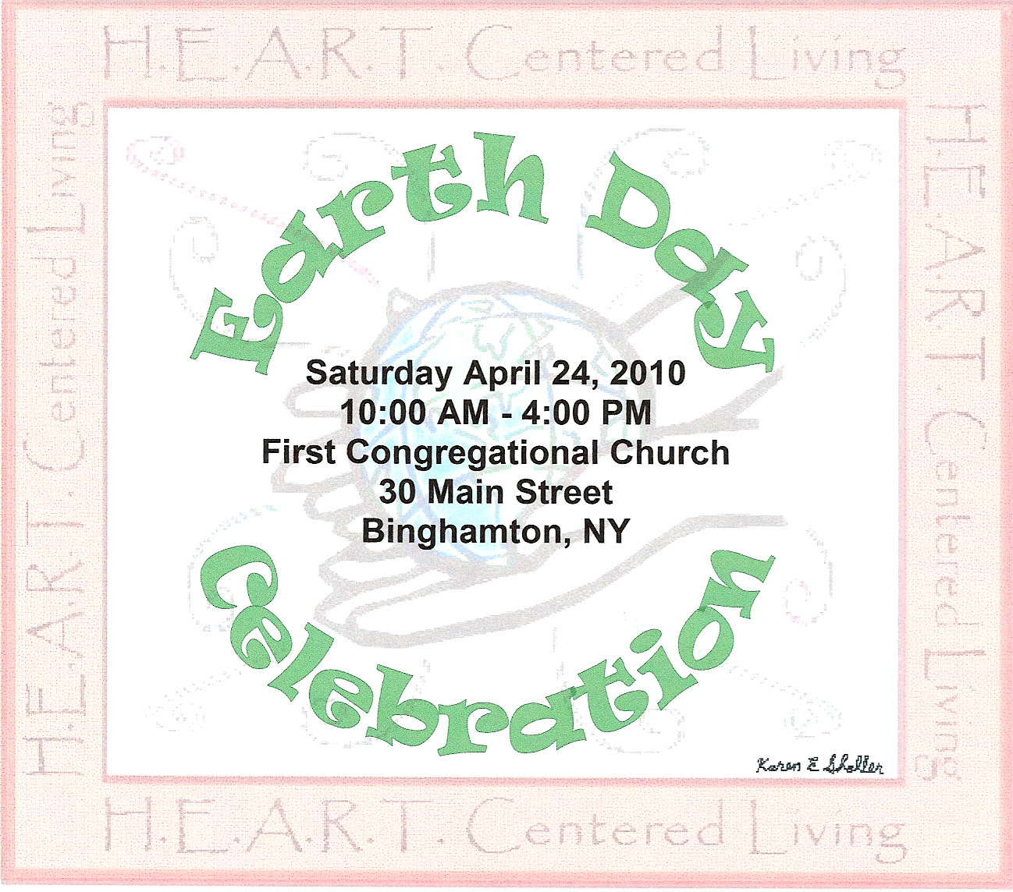

admission is either $1 or a canned good for CHOW

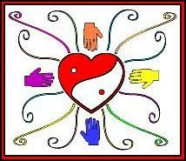
Come join us for a full day of honoring & celebrating Mother Earth.
There will be a world peace meditation ceremony, games for kids,
Demos & Workshops from local vendors & artisans.
Open to the public. Something for everyone.

