JET SKI ALERT

Recently some jet ski tours have been observed operating in Akumal’s Half Moon Bay. This is a very fragile marine environment with live coral throughout, some just inches beneath the water’s surface. It is a prime turtle nesting location as well as a popular snorkel area. Operation of jet skis in this area is very dangerous both to the environment and to the riders.

If you plan to rent jet skis, please make sure that the tour leaders will not be going into any areas where there is potential for harm to either you or the fragile environment. Let them know that it is unacceptable to do so. Have fun, but also please tread lightly on the beautiful Riviera Maya.

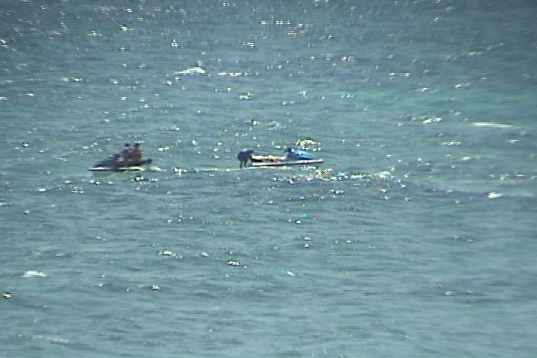
Jet ski tour guide STANDING ON LIVE CORAL in Half Moon Bay!

For more information about environmental issues, please visit the website of the Centro Ecologico Akumal at www.ceakumal.org

