T- OK Will, you probably already know, but let me explain why I’ve asked you to help out today: I’m thinking about using a web site for a lesson in class and I want to see what it’s like for students to use it, like if it’s easy to understand and find your way around in. I’m thinking that this will take from 10 to 20 minutes, OK?
S- Mm Hmm
T- I want to make it clear right away that I’m testing the site, not you. You can’t do anything wrong here. In fact, this is probably the one place today where you don’t have to worry about making mistakes.
I want to hear exactly what you think, don’t worry about hurting my feelings. I didn’t create the pages you’re going to look at. I want to be sure it doesn’t confuse my students, so I need to know honestly what you think.
As we go along, I’m going to ask you to think out loud, to tell me what’s going through your mind as you look at the web site. This will help me a lot.
If you have questions, just ask. I may not be able to answer them right away, since we’re interested in how people do when they don’t have someone sitting next to them, but I will try to answer any questions you still have when we’re done.
I’m going to try to keep us moving, but we’ll try to make sure that it’s fun, too.
You may have noticed the camera. With your permission, I’m going to videotape the computer screen and what you have to say. The video will be used only to help me figure out what you like or don’t like about the site, and it won’t be seen by anyone except me. It also helps me, because I don’t have to take as many notes.
Do you have any questions before we begin?
S- No
T- Before we look at the site, I’d like to ask you just a few quick questions. First, how old are you?
S- Ten (spoken like dad knew better!)
T- Good. Now, roughly how many hours a week would you say you spend using the Internet, at school and at home?
S- I don’t know.
T- Yeah, how often do you use the Internet at school?
S- Like maybe, I don’t know, on computer days though we do it like a lot
T- So when you go to computer class you spend a lot of time on the internet?

S- Yeah but that’s only one day (in a 6 day cycle)
T- Ok, so you don’t really use it in Mrs. Niver’s class
S- Yeah I do, I play Evil Elves on it
T- Mm Hmm Ok, What kind of stuff do you do on the computer when you’re in computer class? S- Create stuff
T- Are there any names of any web sites that you use? That you can think of?
S- Uh, Yahooligans, and mostly they’re really long names that I can’t remember
T- Ok and even though I know this I’m gonna ask you anyway what kind of things you use the computer for at home?
S- Looking up Yu-Gi-OH cards
T- Um, do you have any favorite web sites?
S- Um what is that called, I know I have one but I don’t know what it’s called
T- Ok have you used any
S- Oh, yeah, yeah, Toy Whiz
T- Toy Whiz, ok, what’s cool about that?
S- You can look at cards and stuff except they’re really expensive
T- Oh, (laughs) do you use any educational web sites at school?
S- Um, they have really long names again, so I can’t remember them
T- Ok
S- Well we do use the um, I don’t know what it’s called it’s like um, it’s some big one it’s like the Almanac of Social Studies or whatever
T- Yeah, what do you use that for?
S- Like every social studies thing that we do
T- Oh yeah, it’s like a research thing?
S- Yeah
T- Ok, what do you like or not like about those kinds of sites?
S- They’re boring
T- Yeah? Why are they boring?
S- Because they don’t have any exciting things in ‘em
T- Anything else about them?
S- No
T- OK, great. We’re done with the questions, and we can start looking at things.
T- Ok pull that up (Student maximizes home page of web site that had been minimized) now what I’m looking at here in this web site is uh possibly doing a lesson or using it for a lesson, on forestry and things like that, so it looks like it could be an interesting web site and what we’re going to do is just spend some time quickly seeing if you can figure out how to get around the web site and, um, what do you think you need to do, and how you need to navigate around it, so what’s the first thing that strikes you about this screen, this is the opening screen?
S- It’s interesting
T- Yeah? What’s interesting about it?
S- Because it has like a 3D owl
T- Like an animated owl
S- Uh huh
T- yeah, anything else?
S- No
(See figure 1 for a screen shot of the first page. Note that the images in this document, when viewed online, may appear fuzzy, but should be much clearer when printed out)
T- Ok, what um, what do you think you’re supposed to do from here?
S- Click on one of those (he moves the cursor over the words on the left of the screen)
T- Click on one of those?
(Student clicks on “Introduction” and goes to that screen, see figure 2; this would seem to be the logical thing to do, and thus can be argued to meet usability guidelines)
T- Now, uh, what are you thinking now?
S- um, wait
T- Ok (Student reads Introduction screen)
S- Cool
T- Yeah?
S- Mm hmm
T- Sounds like it’s fun?
S- It’s like a game thing [continued on line 102]

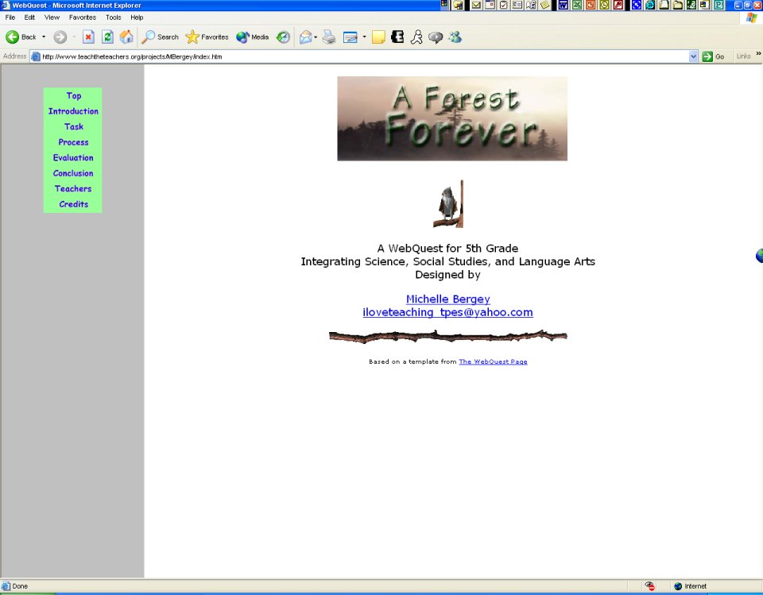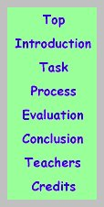
Student says “click on one of those” when asked what to do next, moving cursor over this area; he clicks on Introduction
The left side of the screen is a static frame
This owl is animated
Figure 1, screen shot of 1st page [lines 67-82] | Figure 1A  Close up of navigation buttons on left of screen
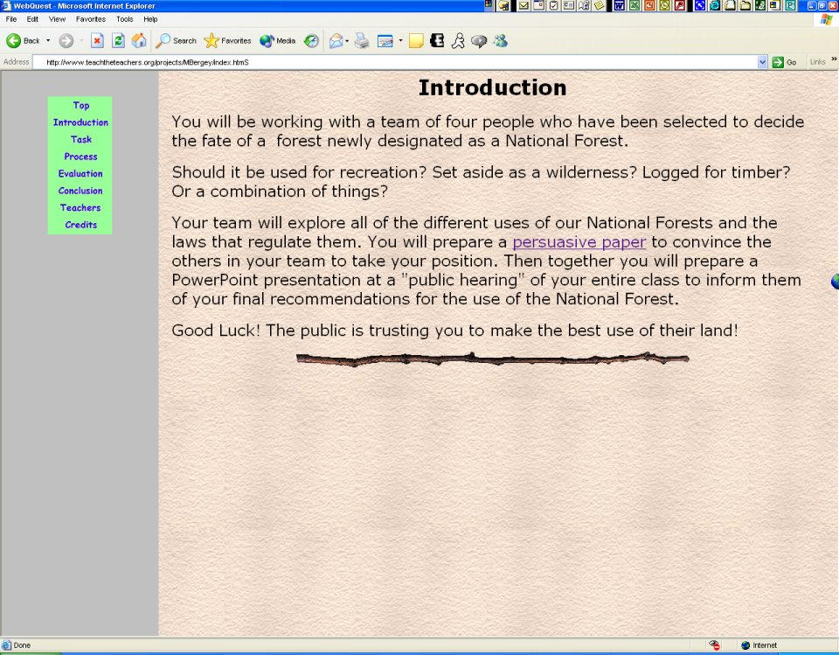
Student is asked to see what this is
Figure 2, Introduction screen [lines 85-94]

T- Oh ok
(Student clicks on “Task”)
T- Could you go back a second?
(Student clicks on “Introduction” again and returns to that screen)
T- Ok, I see something there about “persuasive paper” what do you think, is there anything to do there, or…
(Student clicks on the “persuasive paper” link, see figure 2)
T- Oh, ok
S- I don’t care
T- Ok I just wanted to see if that was anything, uh, did you think to go there before I pointed that out to you?
S- Yeah, but I don’t want to write a persuasive paper (see figure 3)
(Student clicks browser’s Back button to return to Introduction screen, figure 2)
T- No, that’s all right we’re not going to actually do everything
(Student clicks on “Task” without prompting)
S- I know [continued on line 127]

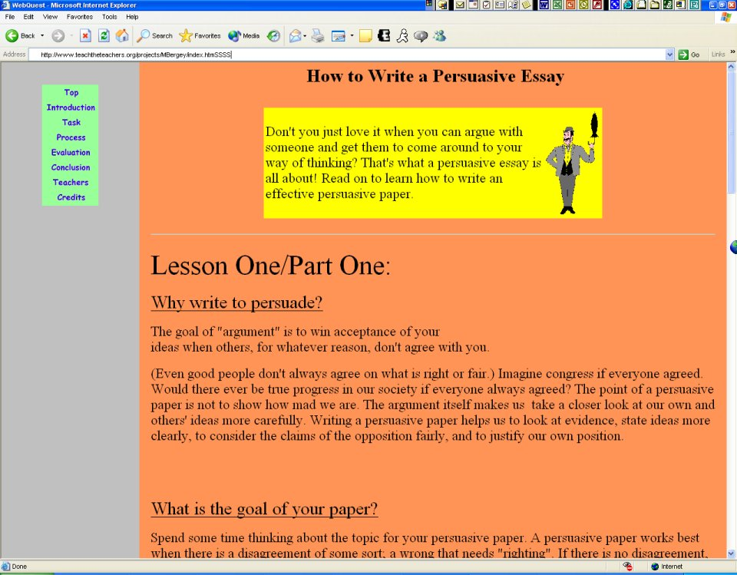
This figure is animated, and in the Teacher’s opinion, pretty annoying! It would probably distract students while they were trying to read the text
Figure 3, Persuasive Paper [lines 108-114]

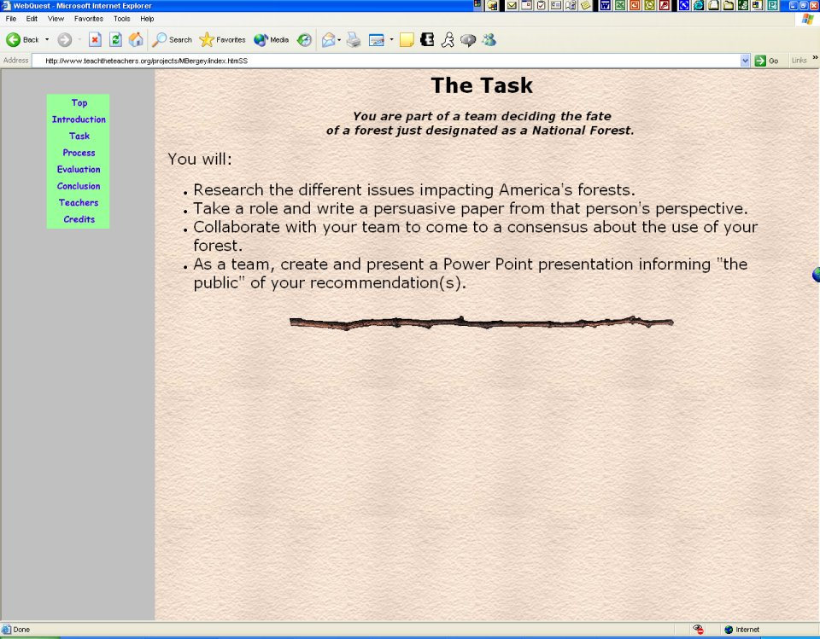
Student repeats that he doesn’t want to write a persuasive paper
Figure 4, The Task [lines 116-128]

(Student reads instructions on “The Task” screen, repeats that he doesn’t want to write a persuasive paper, teacher acknowledges that, see Figure 4)
S- Sounds complicated sounds cool whatever
T- Ok
(Student clicks on “Process” without prompting, reads the screen, see figure 5)
T- All right, now you’re in The Process, let me ask you something, one thing that I’m wondering about, do you ever notice up in the address bar (Teacher points with a pen to the browser’s address bar) as you go from one page to another
S- It’s different
T- It’s different?
S- Mm hmm
T- What’s happening to the addresses in that address bar?
S- Uh, I don’t know?
T- Well, why don’t you go back to “Task”
(Student clicks on “Task”, goes to that screen, then clicks on “Process” and returns to that screen, watching the address bar)
S- It doesn’t change
T- It doesn’t change? [continued on line 150]

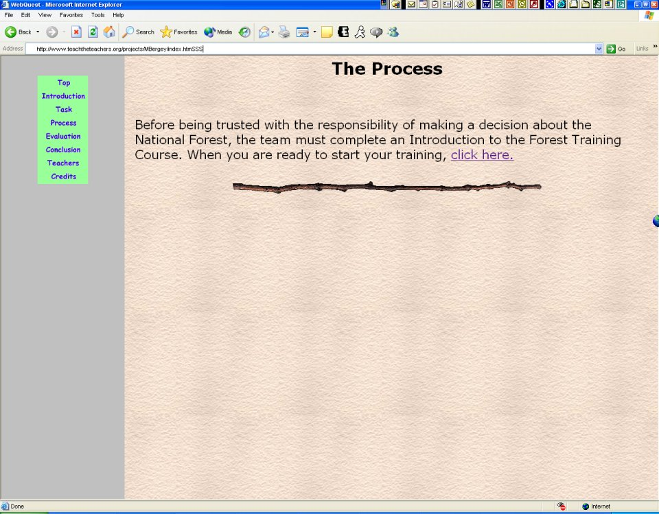
This link goes to the “Welcome to Forest Training” page, figure 6
The URL in the address bar never changes throughout the entire study, due to frames being used in the site design
Figure 5, The Process [lines 131-150]

(Student clicks on “Click Here” on The Process page without prompting, and goes to the “Welcome to Forest Training” page, see figure 6, still watching the address bar)
S- No, it doesn’t change
T- So you go onto a bunch of different web pages but the address stays the same?
S- Mm hmm
(Student clicks on the Next button without prompting, see figure 6, and clicks the Next button on the subsequent page, arriving at the page shown in figure 7)
S- Tree Cookies?
(Student notices link on screen in figure 7, clicks on “Tree Cookies” link, and goes to the page shown in figure 8, then begins to read page shown in figure 8, page loads relatively slowly, student clicks on the browser’s Back button, before the page fully loads, to return to the screen shown in figure 7)
S- Unless you’re a termite you can’t eat tree cookies (Student reads sentence on screen in figure 8)
T- Hang on, let’s uh, want to go back to that?
(Student clicks on Tree Cookies link again, returns to that page, figure 8, which loads more quickly this time due to most of the page elements being cached by the browser) [cont. line 182]

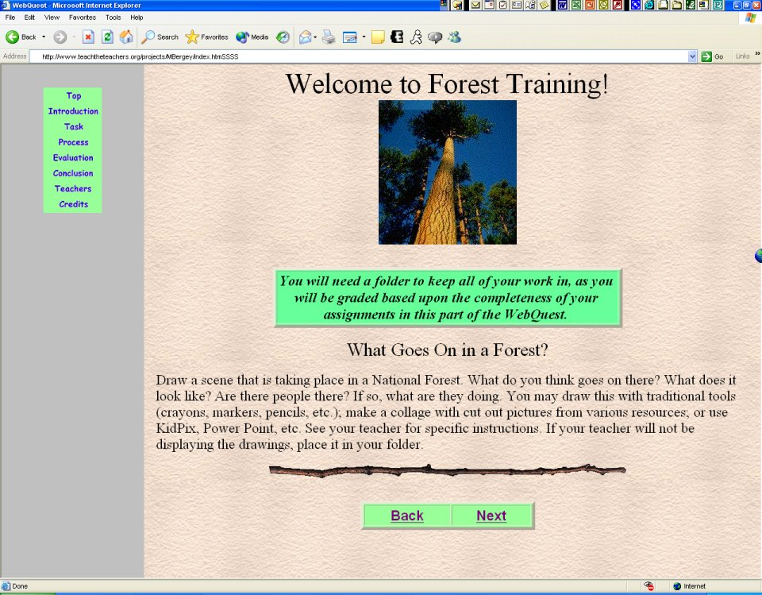
Figure 6, this page is reached by clicking on “click here” on The Process page, figure 5
[lines 151-155]

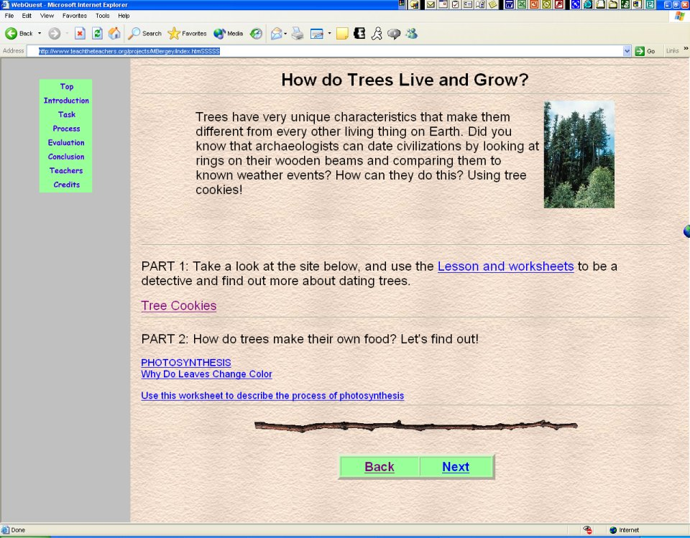
This link captures the Student’s interest
Figure 7, this page is 2 clicks on Next from the page in figure 6 [lines 156-158]

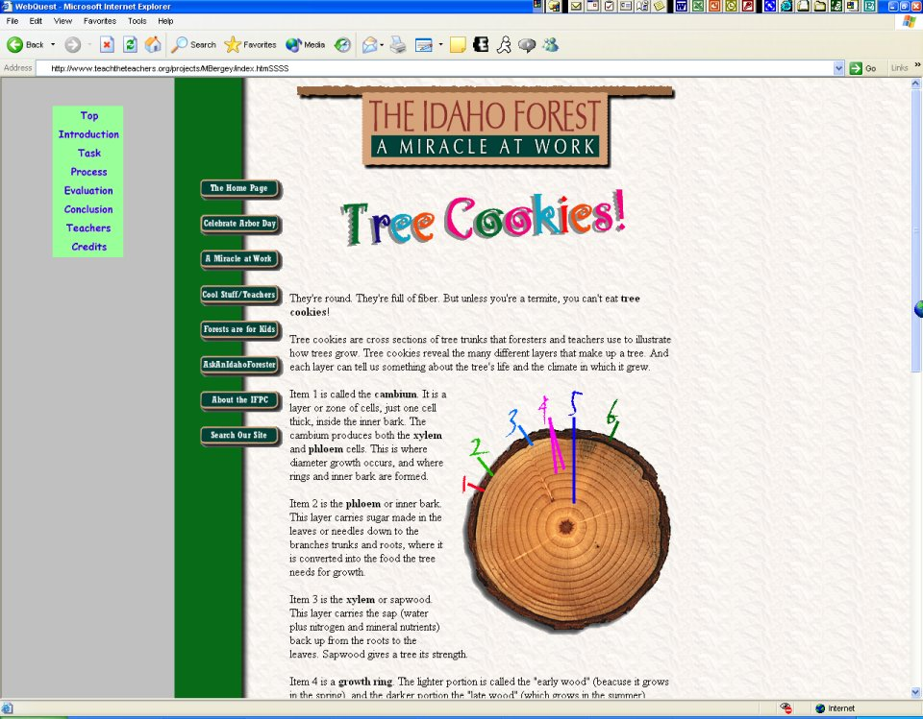
Clicking on “The Home Page” here takes us to the home page of the Idaho Forest Products Commission web site, while still in the frame of the “Forest Forever” lesson site. Confusing?
Cool Stuff/ Teachers link
Sentence reads “But unless you’re a termite, you can’t eat tree cookies!
Figure 8, page reached by clicking on the “Tree Cookies” link in figure 7. [lines 159-165+182-192]
[However, this page is actually part of the Idaho Forest Product Commission’s web site, even though the URL in the browser’s address bar stays the same, as frames are being used.]

T- Ok, now, this kind of looks like it’s different from the place you started in cause I see, I mean we’ve got some things over here that appear to be taking you to different web pages and then there are some things here
(Teacher points with pen first to the primary site’s navigation links on the left side of the screen, enclosed in an oval in figure 8, then points to the Links on the left of the Idaho Forest page, enclosed in a rectangle, with “The Home Page” at the top)
T- So what do you think is going on?
S- Mm, mm just some kind of different thing
T- Want to check out some of that stuff? (Referring to the links on the Idaho Forest page, in the rectangle in figure 8)
S- Yeah sure
S- Ask An Idaho Forester (looking at 3rd link from bottom, but student clicks on 5th link from the bottom, “Cool Stuff/Teachers”, see solid arrows in figure 9A)
S- Hmm, it still doesn’t change (referring to URL in address bar, see figure 9)
T- But now we’re in Idaho Forest Products Commission
S- Hmm, but it’s the same place (moving cursor over address bar) [cont. line 204]

This link says “The Home Page”

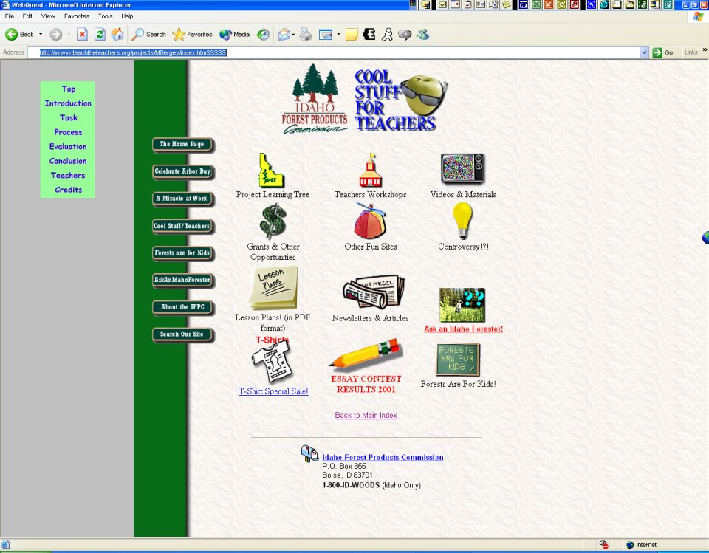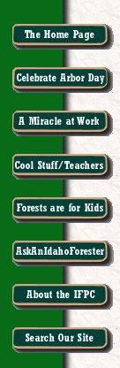
This link says “Top”
Figure 9 [lines 195-206] | Figure 9A [line 194]
URL still does not change in address bar, and which set of links should be used??

T- What do you think is going on?
S- I don’t know
T- Don’t know? What’s the, now we’ve got Top there but The Home Page there (see figure 9) what do you think, before you click it (Student clicks “The Home Page” link before teacher finishes saying ‘before you click it’) oh, so we’re now at the home page… what home page is this? (see figure 10)
(Student looks at teacher and raises his eyebrows in confusion)
S- The Idaho forest thing
T- Huh
S- And the Top is that (clicks on “Top” link, see arrow in figure 10, and returns to screen shown in figure 1)
S- Mmmhhmmmm? (Laughs a little), I don’t know!
T- Yeah? Is it making any sense to you? Can you get back to where you were before?
S- Ohhhh… [cont. line 222]

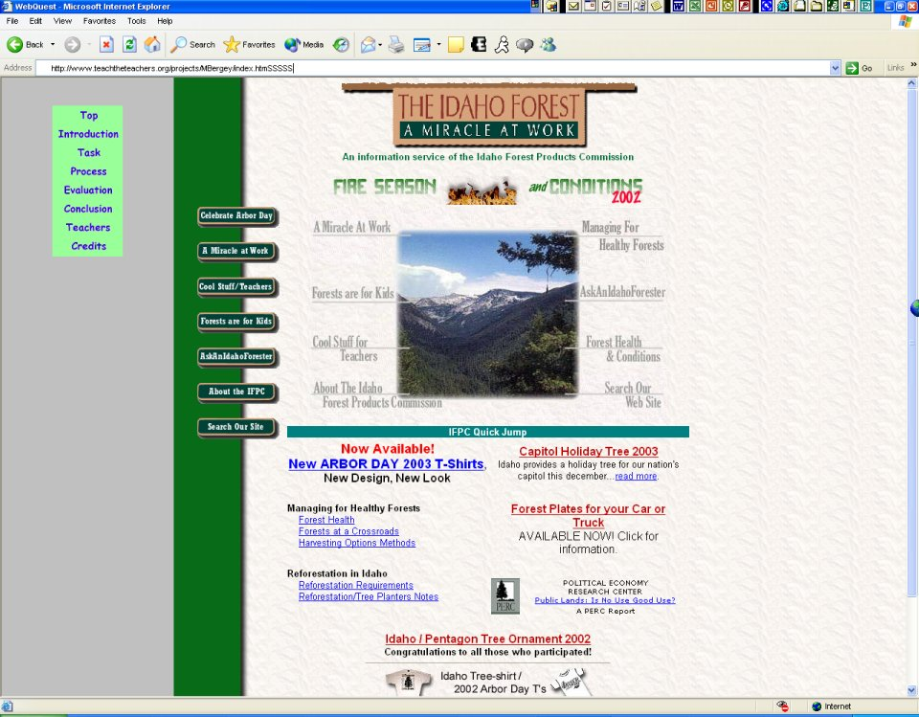
Figure 10, Idaho Forest home page, still within frame of primary site [lines 209-213]

(Student clicks on Process, then on Task, then on Process again, then on Click Here on The Process page, figure 5, then Next on the screen shown in figure 6, then Next on the subsequent screen, to get to the screen shown in figure 7, and then clicks on Tree Cookies again, then on The Home Page as shown in figure 8, to return to the Idaho Forest home page, as shown in figure 10)
T- Wow, huh
S- That’s just the Top, though (moving cursor over Top link on left side of screen) and this is the uh, this is the uh whatever (moving cursor around over the Idaho Forest page and finally the graphic at the top of the page that says “The Idaho Forest; A Miracle at Work”) this is the home page but that’s the Top (again moving cursor over the “Top” link) I don’t know (laughing)
T- Do you understand how, what’s going on here, where you’re going and everything, can you get back to that, to the lesson?
S- Lesson?
T- Yeah
S- Which one?
T- Ah, the one that we started out on
S- The thing with the animated owl?
T- Uh yeah and then beyond that where it was going into what was it the Process or something?
S- Like right here? (clicks on Process on left side of screen)
T- Yeah, but you can’t get back to the

S- Home page?
T- You can get to the home page but you were at that, that page where you first clicked on Tree Cookies
S- Yeah I can go there (repeats the progressive clicking as before, to get back to the Tree Cookies page shown in figure 8)
T- Doesn’t seem like it was very easy to get back to that, does it?
S- Right here!
T- Yeah, ok now can you get back to that other page?
S- You mean the Process?
T- Yeah
S- (Clicks again on Process on left side of screen) Doink!
T- But that didn’t take you back to
S- What?
T- That page in the Process that it said Tree Cookies?
S- Yeah, but I could just go like this... Wait (repeats progressive clicking to get to screen in figure 8)
T- Ok so now you’re there
S- But that’s because I clicked on that (points to Process on left side of screen)
T- You clicked on Process on the left hand side?
S- Yeah, and I can just, yeah that is going all the way back (points to Top link) if you go like that (clicks on The Home Page link, then on the browser’s Back button to return to the Tree Cookies screen shown in figure 8) then you can just go back to it, if you click on Back
T- On the Back, on the uh,
S- Yeah
T- Browser toolbar?
S- Mm hmm
T- Ok, so can we get back into that lesson?
S- You mean the Process?
T- Yeah, well back to the same page where you, before you, where you clicked on Tree Cookies? In the Process?
(Student clicks on browser’s Back button twice to return to screen shown in figure 7)
T- Ok, how do you feel about getting around in those pages, and...
S- Easy [cont. line 281]

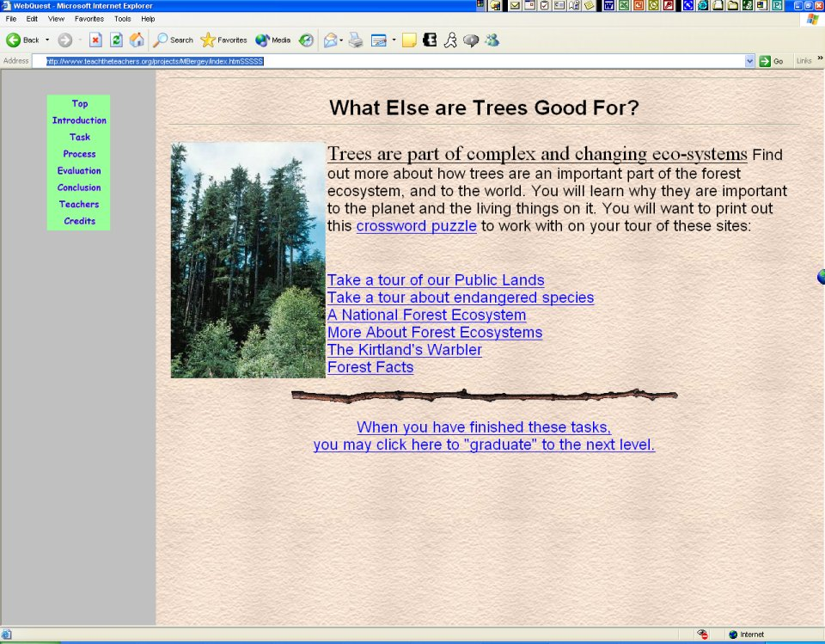
Figure 11 [lines 282-284]

T- Easy? Ok let’s just try a couple more things here and…
(Student clicks on Next button on screen shown in figure 7, goes to screen shown in figure 11)
S- Mm hmm
(Student then clicks on Credits, at the bottom of the links on the left side, see arrow in figure 11, and goes to the page shown in figure 12)
(Then student clicks on Teachers, second from bottom, see figure 12, which takes him to the screen shown in figure 13)
T- Ok, so you’re just…
(Student clicks on Process, see figure 13, and goes to the screen shown in figure 14; student clicks on Process again on this screen after looking at the page for a few moments, and then clicks on Top, which returns him to the screen shown in figure 13, NOT the screen in figure 1! From there he again clicks on Process and returns to the screen shown in figure 14)
S- What?
T- Well, what are we doing there?
(The teacher was also confused about what was going on) [cont. line 318]

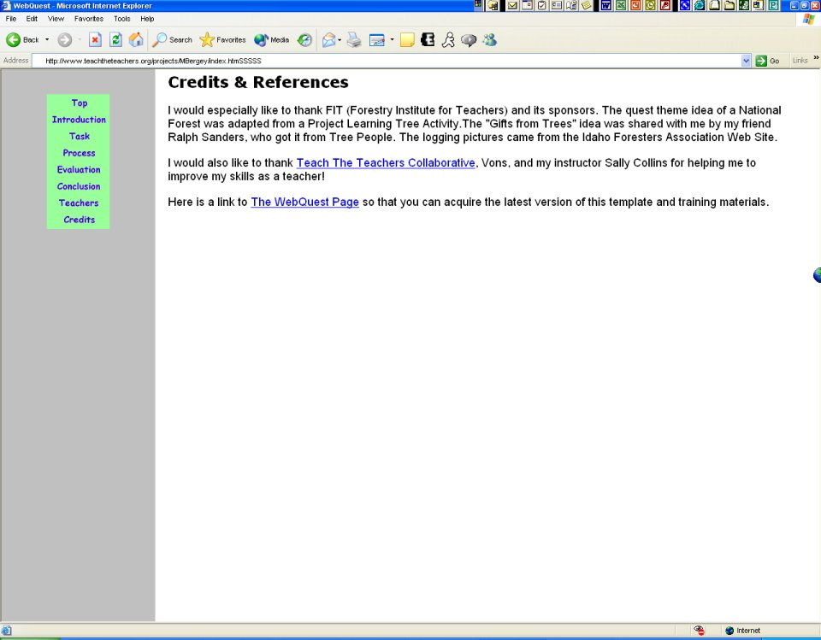
From this page student clicks on Teachers, and goes to the screen in figure 13
Figure 12 [lines 286-287]

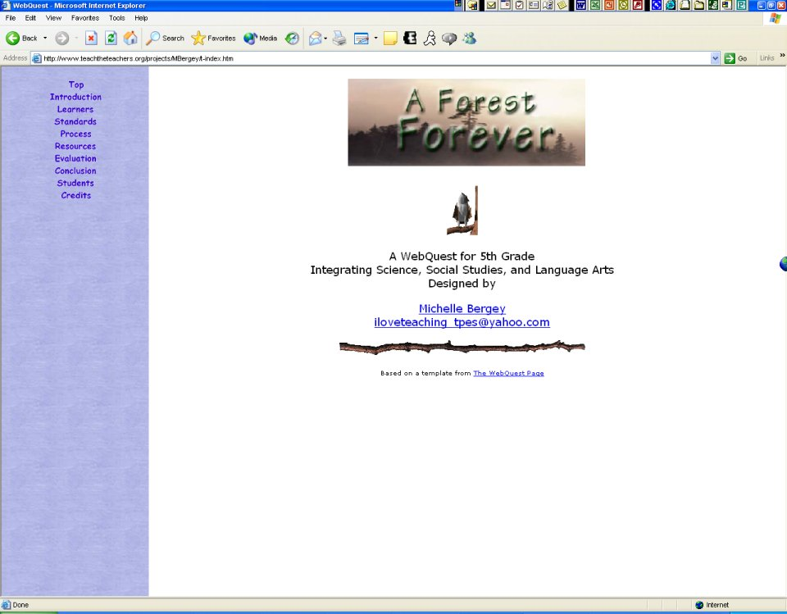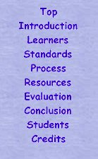
The left hand frame with links looks very similar, at first glance, to the one on the other Top page (figure 1)
Figure 13 This sure LOOKS like the Top page that we started out on | Figure 13A [line 321]
[lines 289-291+326-327]

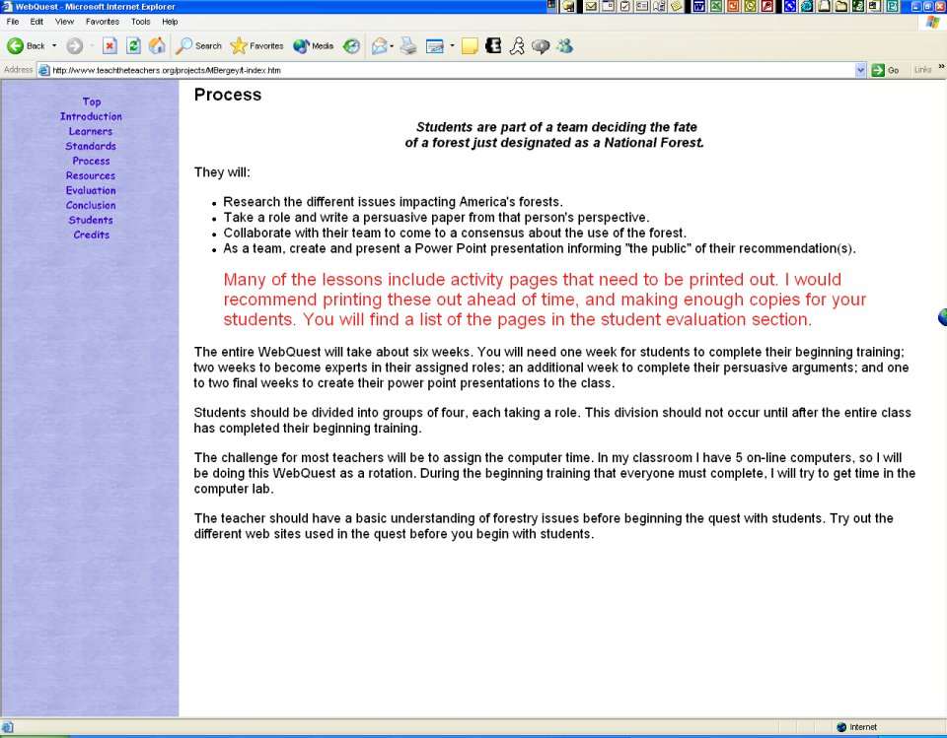
Figure 14 Not the same Process screen shown in figure 5! [lines 289-320+329-331]

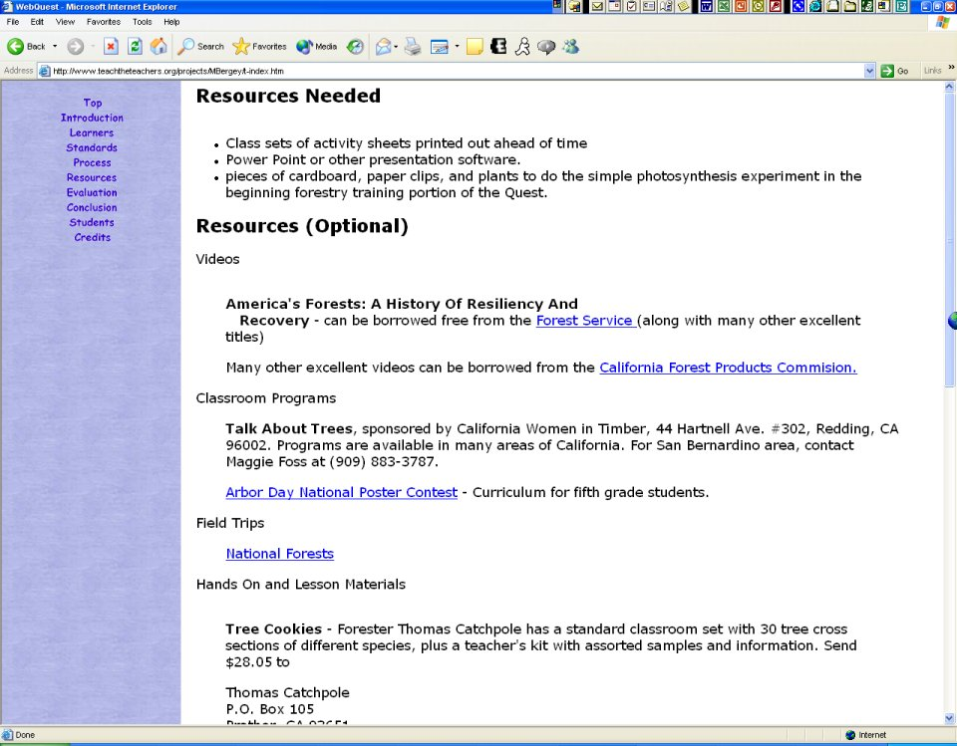
Figure 15 [lines 321-322]

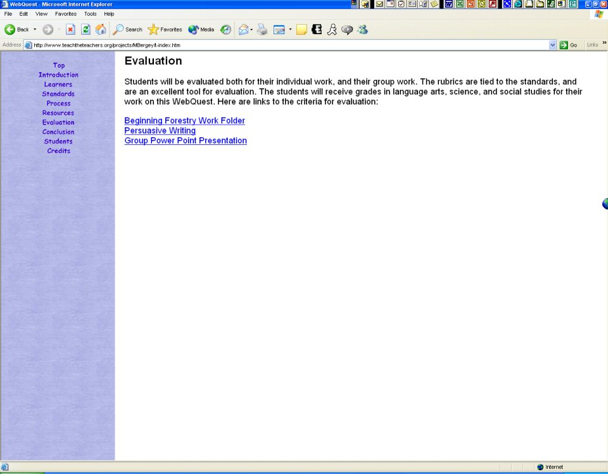
Figure 16 [lines 322-323]

S- I don’t know! Ok now I don’t know what’s happening here
T- Huh
(Student clicks on Resources on left side of screen, as shown by arrow in figure 14, also see figure 13A for a close-up, and goes to the screen shown in figure 15; student then clicks Evaluation, as shown by arrow in figure 15, and goes to the screen shown in figure 16; student clicks Top again, as shown by arrow in figure 16, and returns to screen shown in figure 13, NOT the screen in figure 1)
S- That’s still it
(Student clicks on Introduction, as shown by arrow in figure 13, then goes down the links clicking on Learners, Curriculum Standards, and Process again)
S- That’s not, that’s not, that’s not, that’s not (Student stops on the Process page shown in figure 14, scrolling up and down it, and is trying to figure out what happened to the pages he was first looking at in the beginning, he looks at teacher with raised eyebrows again)
T- I’m totally confused too, what do you think you went into? It looks like the same site, but…
(Student clicks on the browser’s Back button 13 times to get back to the screen shown in figure 7!)
S- Yeah, it looks like it, there! (Screen shown in figure 7)
T- Oh, so you just kept clicking on the Back button a bunch of times, ok

S- Yeah that’s because I like went too far
T- Now if you go forward, if you click the forward button
(Student clicks the Next button instead)
T- Actually I was thinking
(Teacher points to browser’s forward button with pen, student clicks on it even though it’s not active)
T- No, you have to go back
(Student clicks back, then forward, and returns to the same page, see figure 17, that Student got to after clicking the Next button as described above, this was a mistake on the Teacher’s part in giving bad directions)
S- Yeah… yeah?
T- Oh, ok, I’m not sure what I was looking for there…
S- You may click here to graduate to the next level, maybe that’s what I clicked on (see arrow in figure 17)
(Student then clicks on Top, returning to the screen shown in figure 1, then Introduction, figure 2, then Process, figure 5)
S- Yup, that’s probably what I clicked on
(Student then clicks on Click Here on the screen in figure 5 and returns to the screen in figure 7, clicks next, clicks next again arriving at the screen shown in figure 7, then clicks on Tree Cookies to get back to the screen shown in figure 8)
S- Yeah, this is pretty easy to go around in
T- Yeah? Does it look interesting, or…
S- Yeah
T- Something you’d like to do in a class?
S- Mm hmm
T- Ok
S- More interesting than anything I do at my school
T- (laughs)
(Student spends a few moments looking around on the page shown in figure 8, and clicks on Cool Stuff/Teachers link, unprompted, going to screen shown in figure 9)
T- Ok, how about, um…
S- Hmmm
T- We’ve looked at the process a little bit
S- Mm hmm [cont. line 382]
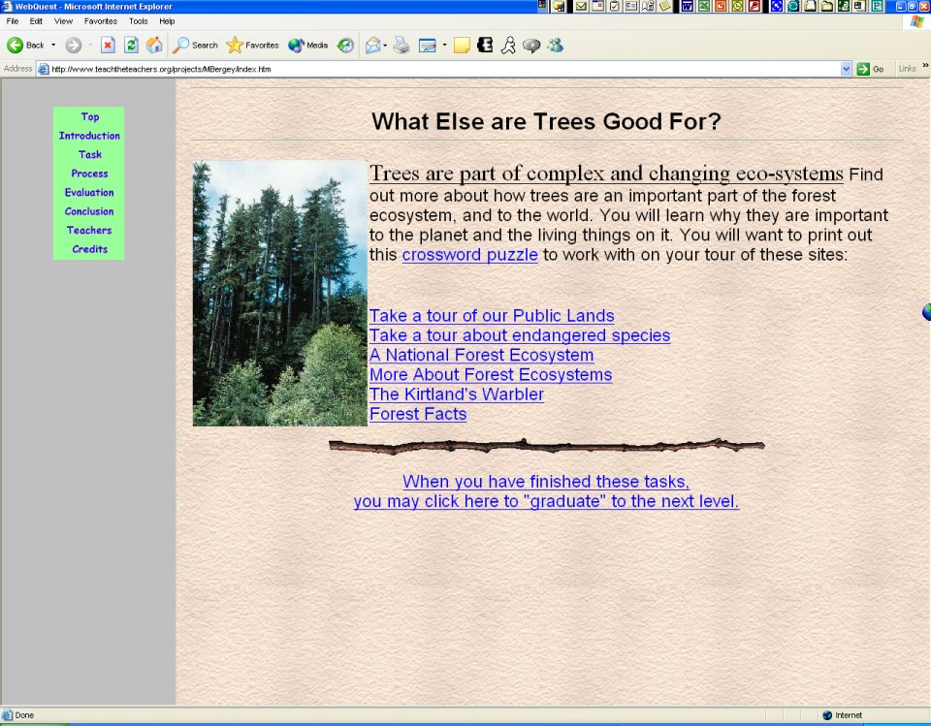
Figure 17 [lines 344-350]

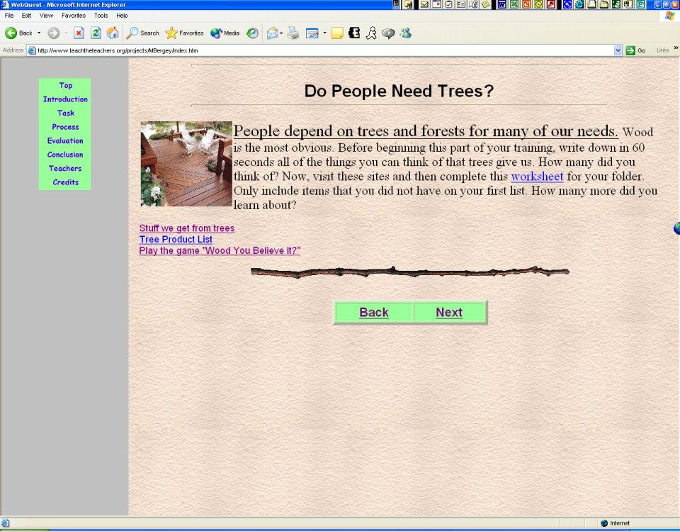
Link for “Wood You Believe It” game
Figure 18 [lines 386-389]

T- And it seems like you’re saying it’s pretty easy to get around in there
S- Yeah
T- Why don’t we go back to process and try
(Student clicks on Process)
T- One other thing and then we’ll move on to the other things...
(Student navigates back to screen shown in figure 18, which is in between the web page screens shown in figures 6 & 7)
T- How about, what have you got there…let’s have you play the game Wood You Believe It (see figure 18)
(Student clicks on link and goes to screen shown in figure 19)
T- Now what’s up with those, what do you make of these here? (Points with pen to link buttons circled in figure 19, with close-up in figure 20)
S- I don’t know
T- Back…
(Student clicks on the back button circled in figure 20, and goes to screen shown in figure 21, looks at teacher with a frown) [cont. line 407]

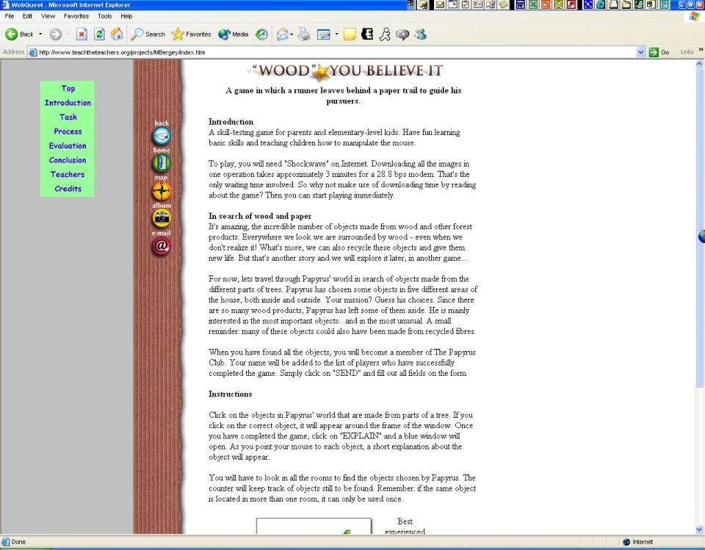
Figure 19 [lines 392-395] | Figure 20 [line 393]
“Wood You Believe It” game introduction page

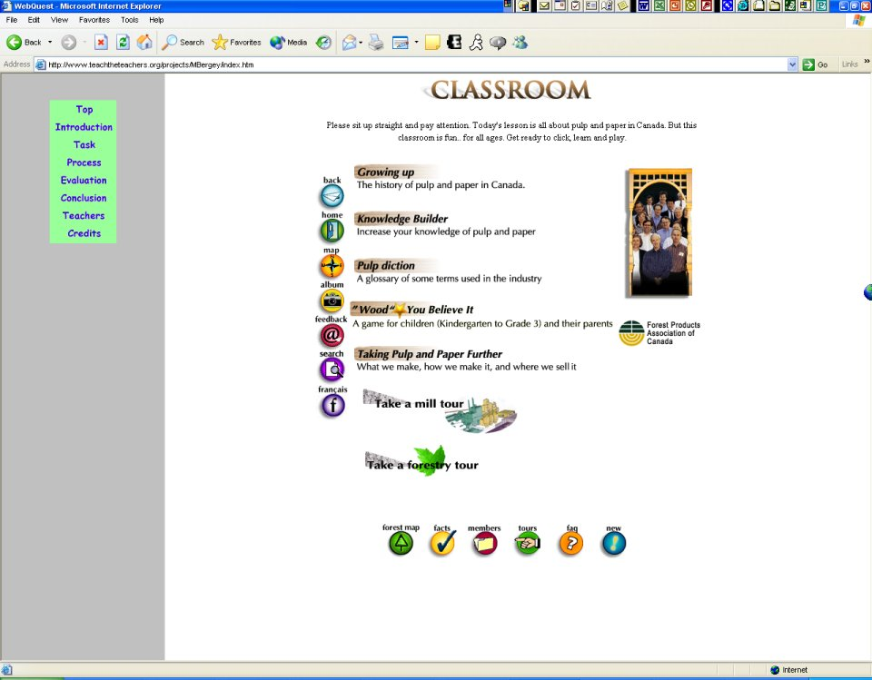
This is another Back button
Figure 21 [lines 395-408]
Clicking on the Back button seen in figure 20 opens this page

T- Sure didn’t take you back to the page you were thinking about, huh?
(Student then clicks on the back button within the screen again, as circled in figure 21, and goes to the screen shown in figure 22; then clicks on the back button within the screen, circled in figures 22 & 23, and goes to the screen shown in figure 24, which appears to be a Flash animation)
T- What in the world is this? Forest Products Association of Canada?
(Student clicks on button labeled English as shown in figure 24, and goes to the same screen shown in figure 22)
S- (Laughs a bit) I don’t know…
T- Hmmm
(Student then clicks on Process again on left side of screen, as indicated by arrow in figure 24, and returns to the screen shown in figure 5, clicks again on Click Here, clicks Next on the subsequent screen, figure 18, then clicks on the Wood You Believe It link, going to the screen in figure 19)
T- Now it seems like to get back to where you were, you’ve gotta keep going back to Process and then going [cont. line 431]
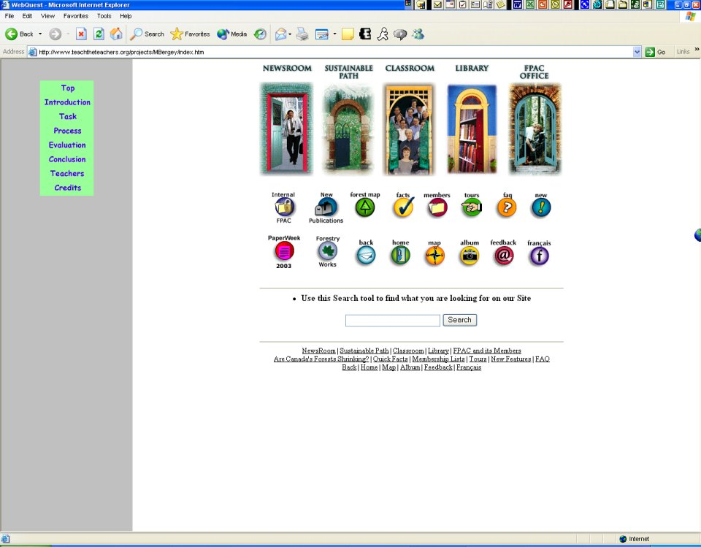
Figure 22 [lines 409-414]
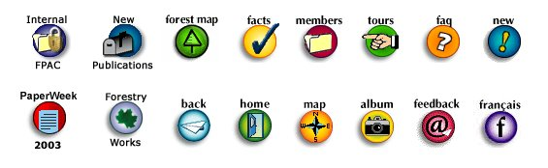
Figure 23, close-up of the buttons in figure 22 [lines 410 + 414]
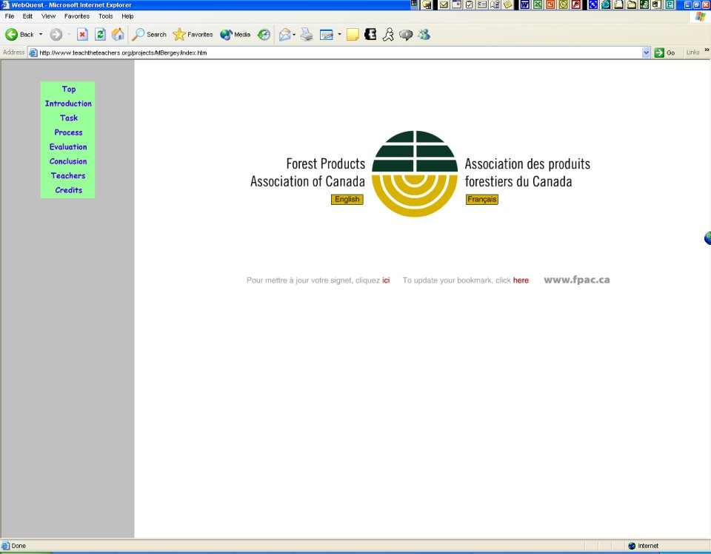
Button says “English”
Figure 24 [lines 413-417]

S- Yeah
T- Through the whole Process from the beginning page of that again
S- No, actually you could just click Back (moves cursor over the browser’s Back button)
T- Yeah
S- Well actually we can’t play that anyway because we don’t have Shockwave (referring to the Wood You Believe It game, he was looking at the opening page for it during the conversation and the link to the game indicated it needed to Shockwave browser plug-in)
T- Yeah right, I was just curious if we could get around… all right why don’t we uh, go over to Evaluation, let’s see what that’s about
(Student clicks on Evaluation, which is immediately beneath Process on the left side of the screen, and goes to the screen shown in figure 25; student and teacher look at page for a moment)
T- Why don’t you click on one just to see what’s up
(Student clicks on Group Power Point Presentation, as shown by the arrow in figure 25, and goes to the screen shown in figure 26)
T- Ok, so there’s a rubric
(Student scrolls the page a little) [cont. line 463]

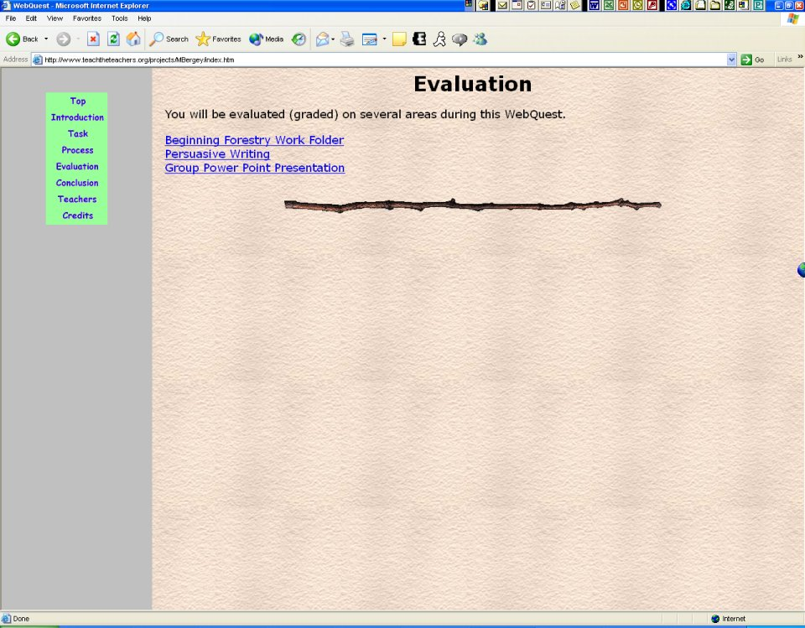
Figure 25 [lines 440-443]

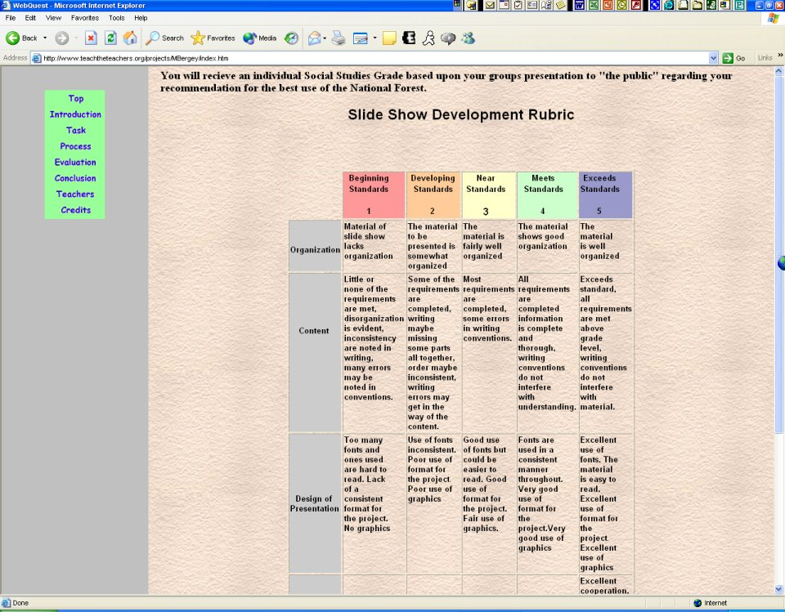
Figure 26 [lines 444-446 +463]

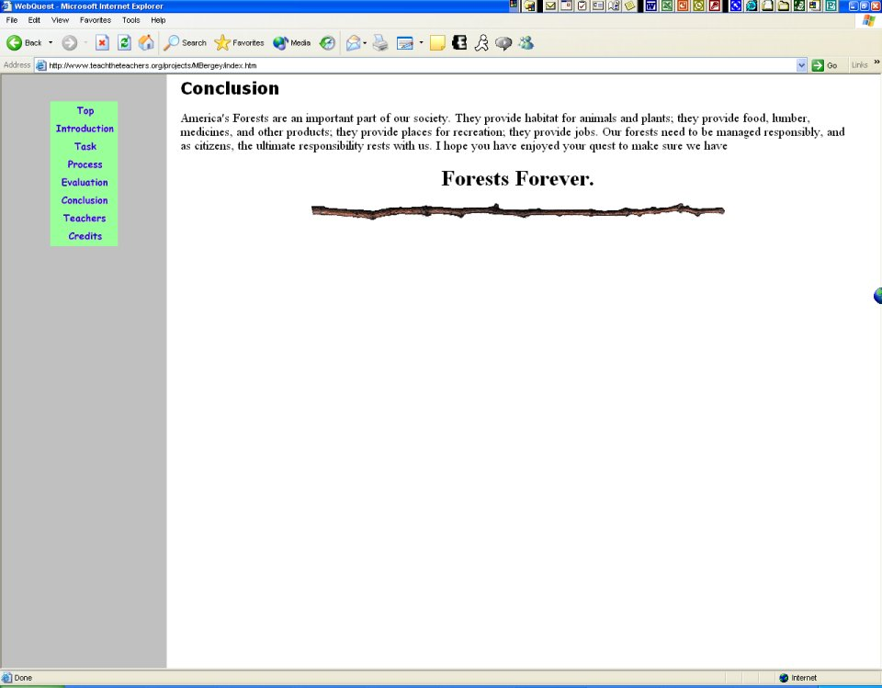
Figure 27 [lines 464-468]

T- Ok, ok, how about Conclusion? We’re just about done here
(Student clicks on Conclusion on the left side of the screen, as shown by the arrow in figure 26, and goes to the screen shown in figure 27)
(Student and Teacher look at the screen for a moment)
T- Ok
S- Hmm
(Student clicks on Teachers without prompting, as shown by the arrow in figure 27, and goes to the screen shown in figure 13!)
T- Hmm, what’s Credits?
(Student clicks on Credits at the bottom of the links on the left of the screen in figure 13, as shown close-up in figure 28, and goes to the screen shown in figure 29; then clicks on Students, as seen in figure 28, and goes to the screen shown in Figure 1! He clicks on Teachers, as shown by the arrow in figure 27, and returns to the screen shown in figure 13)
S- Dude, oh, that’s a whole different thing! (Realizing that the screen shown in figure 13 is different from the screen in figure 1)
T- Huh [cont. line 483]

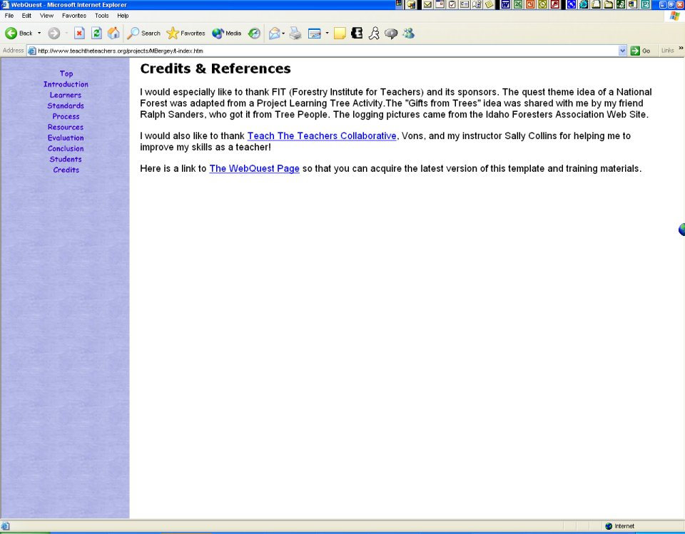
Figure 28 | Figure 29 [lines 472-473]
[lines 472-473+483]

S- OH that’s what I clicked on! (Student clicks on Standards, and then Process, then Students as shown by the arrows in figure 28, then clicks on Teachers from the screen shown in figure 1 & 1A) That’s for students, this is for teachers, there’s a whole different thing for students and a whole different thing for teachers
T- Oh… that wasn’t clear to you though when you first went on it, was it?
S- No
T- So you kind of got lost there for a while, because it looked like the same site
S- Yeahhhhh
T- But, ok do you think that would be a problem for other students?
S- Yeah!
T- Yeah
S- ‘Cause they wouldn’t know what happened
(Student continues to “click around” on the links, going back and forth)
T- Yeah, ok, but when you go to Conclusion it goes back to the same place huh?
S- No
T- Oh
S- Students
T- Oh!
S- Because there’s one for teachers and one for students
T- OH! OK but you think that would be confusing?
S- Yeah!
T- So what’s your overall impression of this web site?
S- It’s ok
T- Yeah?
S- It’s kind of confusing, but…
T- Yeah
S- Cause you keep on going back to the same place, yeah it’s ok
T- Yeah, but it’s a little confusing, ok
S- We done yet?
T- Sure, I think that does it, that gives me, I might have to look at this web site a little more and decide if I do want to use it or not, but, um, you think that if students…
S- If you use it you’ll want to tell people that there’s one for students and one for teachers
T- Yeah that’s a good point; I hadn’t realized that, I hadn’t even really gone into that part. Cool! Thank you very much!

