INTRODUCTION

There are a number of areas in ribbon collecting (Police, Fire Service, Regimentals, etc.) where there is little easily readily accessible information. The ribbons are often mentioned in the standard works but are not catalogued as a whole and such information as we do have may be lost if we do not make a record of what is known. I have in mind putting together a list based on the ribbons I, and fellow collectors, have or know about, starting with British Fire Service ribbons based on my own collection and that of Derek Richardson. It is almost inevitable that there will be mistakes and omissions; but we hope that if anyone can add verifiable information/correction to this listing that they will let us know so that the list can be updated for the benefit of all ribbon collectors. I am grateful to Fred Reid and Henry Tilling for additional information, about ribbons seen at Bressingham Museum and for their good advice.

BRITISH FIRE SERVICE RIBBONS

Prior to 1954 when the Queen’s Fire Service Medal and the official Fire Brigade L.S.&.G.C. Medal were instituted a number of local authorities, companies and Fire Brigade Associations issued their own medals for gallantry and/or service. Locally issued medals largely fell into disuse after 1954 although medals are still awarded by the British Fire Service Association which incorporates the National Fire Brigades Association and the Professional Fire Brigades Association¹. These Notes start with the BFSA, NFBA and PFBA ribbons then move on to local authorities and company awards including ribbons worn by Salvage Corps. The following points should be noted:
a Not surprisingly a large number of red ribbons were used by the Fire
Services. Maroon ribbons often have a purple shade, sometimes described as
‘plum’. The Fire Services also used bright red ribbons similar to that used for the
Police Visit to Scotland Medal, 1903.
It has also become apparent that the same ribbon may appear in a number of
shades over the years. For instance Fred Reid says that ribbons 28 & 30 are ‘very
deep red’ whereas I have seen both these ribbons on medals as shown in the chart.
Similarly, ribbon 33 is usually shown as in the chart but I also have a piece, which
came from the old LCC store and which has stripes of very deep red (34).
b Blue ribbons were also often used, some were very dark as for the Q.V. Police
Jubilee Medals others were a bright blue similar to that used for the Sardinian
Medal for the Crimea.
No doubt the comments in Note (a) apply equally to blue ribbons.
c Ribbons described are nominally 1¼” (32mm) unless otherwise stated.
d The numbers in the left margin refer to the ribbon numbers on the attached chart.

Mike Shepherd

© M.J. SHEPHERD, 2006

Note: ¹ Tapprel Dorling, p.175

British Fire Services Association
- Conspicuous Gallantry Medal
(Dark red watering through light red to a white centre)
2 Meritorious Service Medal (Silver grey/black/red<<)
3 Service Medal (Red/white/black/grey<<)
Prior to 2006 the service medal ribbon was worn for 10 yrs service, a small rosette
was worn on the ribbon after 20 yrs (4), 2 rosettes were worn after 30 yrs and a
silver oak leaf (similar to a WW I MID) was worn after 35 yrs service (5).
6 In 2006 the BFSA announced the issue of a new Bronze medal awarded for 10
yrs service, with a small rosette for 15 yrs service. (White/red/black/grey<<)
At 20 years a silver medal is issued which is suspended from Ribbon (3) above
with a rosette for each additional 5 yrs.
- Centenary Medal (1½” (38mm) wide)
(Red/white/black/orange/grey/yellow/black<<)
8 Foreign Honorary Members Medal (1½” (38mm) wide)) (Grey/red/white<<)
9 Honorary Life Member (Maroon)

National Fire Brigades Union/Association
- Conspicuous Gallantry Decoration
(Dark red watering through light red to a white centre)
10 Meritorious Service Medal
(Maroon with 2 bright red stripes 1/8” wide 3/32” apart in the centre)
11 Honorary Life Member Medal (Dark blue)
12 Service Medal (Bronze), 1893 (10 yrs service) (Purple Maroon)
13 Service Medal (Silver), 1910 (20 yrs service)
(Purple Maroon with a central 1/8” white stripe)
- Service Medal (Type II), 1919 issued for 10 yrs service with a badge device on the
ribbon for each additional 5 yrs service (Red/yellow/navy blue<<). A similar
ribbon with wider yellow stripes was used in Leicester in the 1960/70’s (see 50).
15 Medal for South Africa (Ambulance Dept.) 1899-1902 (White/blue/white/red<<)
16 For Services Rendered (WW I) Medal, 1920
(Blue/red/light blue<< - the very thin black lines separate the colours with is a
very thin black line at each edge. The ribbon is known with and without a central
black line.)
17 N.F.B.U. Service Medal, 1893 (28mm wide) (Blue/white/red)

Professional Fire Brigades Association
18 Meritorious Service Medal (1.3/8” wide (35mm)) (Blue/white/red<<)
19 Long Service Medal Type I (1½” (38mm)) (Red with 2 white stripes)
20 Long Service Medal Type II (1.3/8” wide (35mm)) Grey/white/red<<)
This ribbon is also known in a 1¼” width (21) which provides a better fit to the suspension bar of the medal.
The Medal Yearbook² quotes a (Black/white/red<<) ribbon being used with the silver medal awarded by the Association of Professional Fire Brigade Officers which, from its’ description, would appear to be the above Long Service Medal as described by Faulconbridge - I have not found any other reference for this ribbon.
22 Prize Medal (1.3/8” (35mm) wide) (Red/white/blue<<)

² Medals Yearbook, 2003, item 286A

Birmingham Fire Brigade Association
23 Conspicuous Gallantry Medal
(Red/orange/red<< - the colours are bordered by a very thin black line)
24 Meritorious Service Medal
(Blue/red/yellow/blue<< - the colours are bordered by thin black lines)
25 Service Medal 1906
(Blue/yellow/red<< - the colours are separated by thin black lines)
26 Long Service Medal (Red/white/red<<)
Ribbons 25 & 26 are incorporated into a commonly seen double ribbon (27).

London Private Fire Brigades Association
- Distinguished Service Medal (Red/white/red/white<<)
29 Long Service Medal Type I (maroon)
- Long Service Medal (Type II) (Red/white/red)
See note (a)

Federation of British Fire Services
31 Federation Medal (Red/white/blue<<)

Surrey Fire Brigade Association
32 Association Medal (1½” (38mm) wide) (Red)

Local Authority Fire Brigades/Salvage Corps Ribbons
Service Medals unless otherwise specified

London County Council
33 Medal for Bravery Type I (Red/white/red<<)
34 Medal for Bravery Type II (Very deep red/white/very deep red<<)
See note (a)
35 Medal for Zeal (Golden yellow)
36 London Salvage Corps (White/mulberry/grey blue/white)
The Type I ribbon has corded edges, the Type II ribbon does not have corded
edges, it is wider (36mm) and the edge stripes are buff rather than white (37).
38 Liverpool Fire Brigade (1½” (38mm) wide) (Red)
39 Liverpool Salvage Corps (1.3/8” (35mm) wide) (White/red/black/white<<)
40 Glasgow Corporation Bravery Medal (Red/green/red)
41 Glasgow F. B. (Green/red/green<<)
42 Glasgow Salvage Corps (White/green/white<<)
43 Glasgow Rates & Salvage Assoc. Medal, 1902 (1.7/16” (37mm) wide (Blue)
44 Brighton Volunteer F.B. Gallantry Medal (Grey/blue/white/yellow/black/red<<)
45 Brighton Volunteer F.B. (20 yrs) (Red/blue/red)
46 West Ham F.B Service Medal, 1902 (1½” (38mm) wide) (Blue)
47 Manchester F.B. (1½” (38mm) wide) (Grey blue)
- Reigate F.B. (Blue/red/blue)
This ribbon may have a 2mm black stripe between the red and blue colours.
49 Tottenham F.B. (Blue/red/white<<)
50 Bradford F.B. L.S.M. (Red/yellow/navy blued<<)
51 Finchley F.B. (Maroon/dark blue/maroon)
52 Leyton U.D. F.B. (1.3/8” (35mm) wide) (White/blue/white<<)
53 Norfolk Fire Brigades Association (Red/white/red<<)
54 Leith Volunteer F.B. WW I Service (Dark blue)
54 West Ham F.B. WW I Service Medal (Dark blue)
54 Margate F.B. WW I Service Medal (Dark blue)
55 Acton Volunteer F.B. Coronation Medal 1911 (28mm wide) (Blue/white/red)
56 Surrey F.B. (Black/yellow/red<<)
57 Windlesham F.B. (Pale grey blue)
58 Bradford City F.B. Special Award
(Red/v. dark blue/red<< - with a very thin white line in the centre of the ribbon)
This ribbon is also known with a 2mm central yellow stripe.
59 Basingstoke Volunteer F.B.(Maroon)
59 Chiswick U.D. Volunteer F.B. (Maroon)
59 London Private F.B. Assocation (Maroon)
59 Poole F.B. (Maroon)
59 Todmorden F.B. (Maroon)
59 Ventnor F.B. (Maroon)
59 West Ham F.B.Gallantry Medal (Maroon)
60 Acton Volunteer F.B. (Bright red)
60 Rochdale F.B. Gallantry Medal (1” (26mm) wide) (Bright red)
60 Chiswick U.D. Volunteer F.B. Services Rendered Medal (Bright red)
60 Leek F.B. (Bright red)
60 Metropolitan F.B.– pre L.C.C. 1873-1907 (Bright red)
60 Twickenham F.B. WW I Service Medal (Bright red)
60 Walthamstow U.D. F.B. (Bright red)
61 Smethwick F.B. (Bright blue)
62 Margate F.B. (1½” (38mm) wide) (Black)
- Southampton F.B. (7/8” (22mm) wide) (Maroon)
This medal is also known with ribbon 59 on a straight suspension bar – Type II?
64 Southampton F.B. Lifesaving Medal (White/red/white)
65 Cardiff F.B. Medal for Conspicuous Bravery
(Yellow with 3 red chevrons on the suspension ribbon), worn with 1 chevron on
the ribbon bar (66)
67 Edinburgh F.B. Medal for Valour (Black/white)
68 Newcastle F.B. (Blue/white/orange<<)
69 Stalham F.B. (Blue/white/blue<<)
69 Chiswick Prize Medal 1883 (Blue/white/blue<<)
70 Wymondham F.B. Centenary Medal (Dk. blue/red/dk. blue<<)
71 Norfolk Fire Service (Red/dk. blue/green)
72 Norfolk F.B. Association (1½” (38mm) wide) (Pale blue/purple/off-white<<)
73 Norfolk F. B.Chairman’s Badge (1½” (38mm) wide) (Puce/white/puce<<)
74 Norfolk F.B. Service Medal (26mm wide) (Sky blue/white/sky blue<<)
75 Banbury F.B. (40mm wide) (Grey blue/crimson/grey blue<<)
76 Guernsey F.S. M.S.M. (Green/white/red/yellow<<)
77 Lancashire F.B. Association (35mm wide) (Black/orange/white<<
78 Welsh F.B. & Reserve (35mm wide) (Yellow/black/red/white<<)
79 Kent F.B. Outstanding Service Medal (36mm wide)
(medium blue/light blue/medium blue<<)

Company Fire Brigade Ribbons
Service Medals unless otherwise specified

Birmingham District Industrial F.B. Association
- D.S.M. (Blue/yellow)
81 L..S.M. (Red/yellow/navy blue<<)
82 Sperry Giro F.B. (Blue/red/blue<<)
83 Clark Nicols & Coombe (Clarnico) F.B. Type I (White/red/dark blue<<)
84 Clarnico F.B. Type II) (White/red/blue<<)
85 Watson’s F.B. (Grey watering into Red << - with a central white stripe)
54 Cannon (Bilston) F.B. (Dark blue)
86 Coventry Industrial F.B. (Red/yellow/green<<)
59 Co-operative Wholesale Society F.B. (Maroon)
54 Co-operative Wholesale Society F.B. Golden Jubilee Medal 1913 (Dark blue)
54 Campfield Press (St Albans) F.B. (Dark blue)
87 Cadbury’s F.S. Services Rendered Medal (Blue purple/gold/red<<)
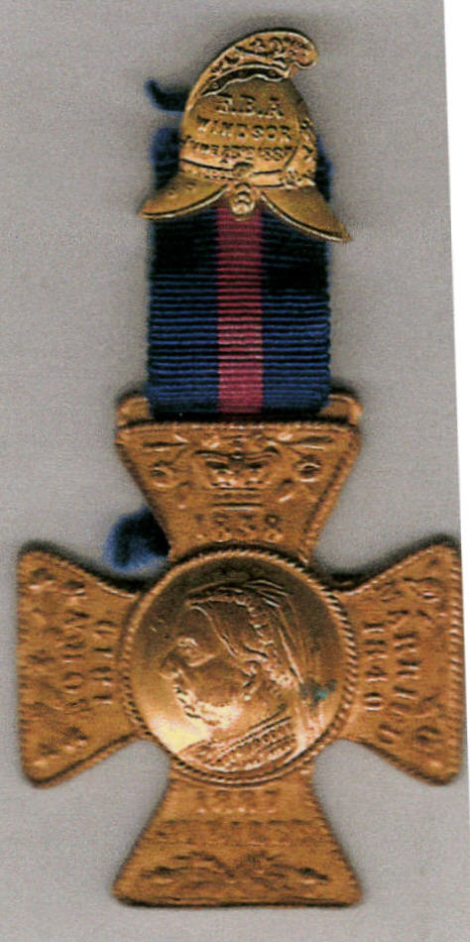

Windsor F.B.A. Jubilee Medal 1887
REFERENCES
Faulconbridge B.G. ‘The Medals and Awards of the British Fire Services Association and its constituent bodies.’ Published in Spink’s Numismatic Circular, 1979
Jocelyn A ‘Awards of Honour’, 1956
Medal Yearbook 2003
Rosignoli G. Ribbons of Orders Decorations & Medals, 1976
Tapprel Dorling H., ‘Ribbon & Medals,’ 1974 edn. (p.175)
Grierson Collection Sales Catalogue, 2004
Fforde & Richardson Collections

